**Coordinate Algebra**

NOTES

**6.2 Partitioning Segments**

**Vocabulary:**

**Partition**- to divide an object into parts.

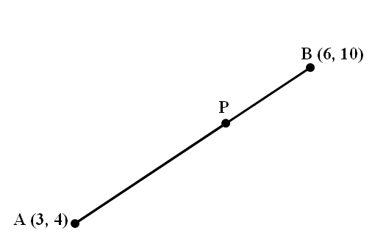**Ratio**- the comparison of two numbers. Ex. The ratio of a to b can be written as a:b or .

**Directed Segment**-shows direction from the starting point to the end point.

For example, means start at Point A and go to Point B.

So point A must be labeled A(x1, y1) and B(x2, y2).

***Example:*** Given the points A(3, 4) and B(6, 10), find the coordinates of the point P on the directed line segment  that partitions  using the ratio 3:2.

* 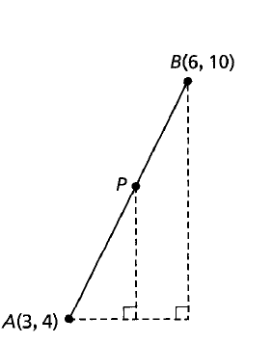**Partitioning a Directed Line Segment: Steps**

1. Label your points (x1, y1) and (x2, y2). Note: since it is a directed segment, **order does matter**.

2. Convert the given ratio into a fraction, so ***a:b ->*** 

3. Find the rise and run for the segment (**order does matter**)

Rise = y2 – y1 Run = x2 – x1

Rise = ____ - ____ = ____ Run = ____ - ____ = ____

4. To find the partitioning point P:

*x*-coordinate= x1 + (ratio as a fraction)(run)

x = ____ + (____)(____) = ____

P(___, ___)

*y*-coordinate = y1 + (ratio as a fraction)(rise)

y = ____ + (____)(____) = ____

*SO WHAT DID I FIND??? P* is the point that partitions AB into the ratio of 3:2.

**Practice Problems**

1. Find the coordinates of the point *P* that lies along the directed segment from C(-3, -2) to D(6,1) and partitions the segment using the ratio 2 to 1.

2. Given the points M(5, -2) and N(-5, 3), find the coordinates of the point P on the directed line segment  that partitions  using the ratio 1:3.

3. Find the coordinates of the point *P* that lies along the directed segment from J(-2,5) to K(2, -3) and partitions the segment using the ratio 4 to 1.

4. Find the coordinates of the point *P* that lies along the directed segment from R(-3, -4) to S(5,0) and partitions the segment using the ratio 2:3.

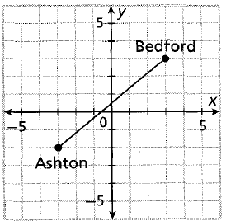5. The map shows a straight highway between two towns. Highway planners want to build a new rest stop between the towns so that the rest stops divide the highway using the ratio 1:2. Find the coordinates of the point at which the rest stop should be built.